**DAY-2**

Created a **database** named as **pet_adoption** and using the database with **use** command.

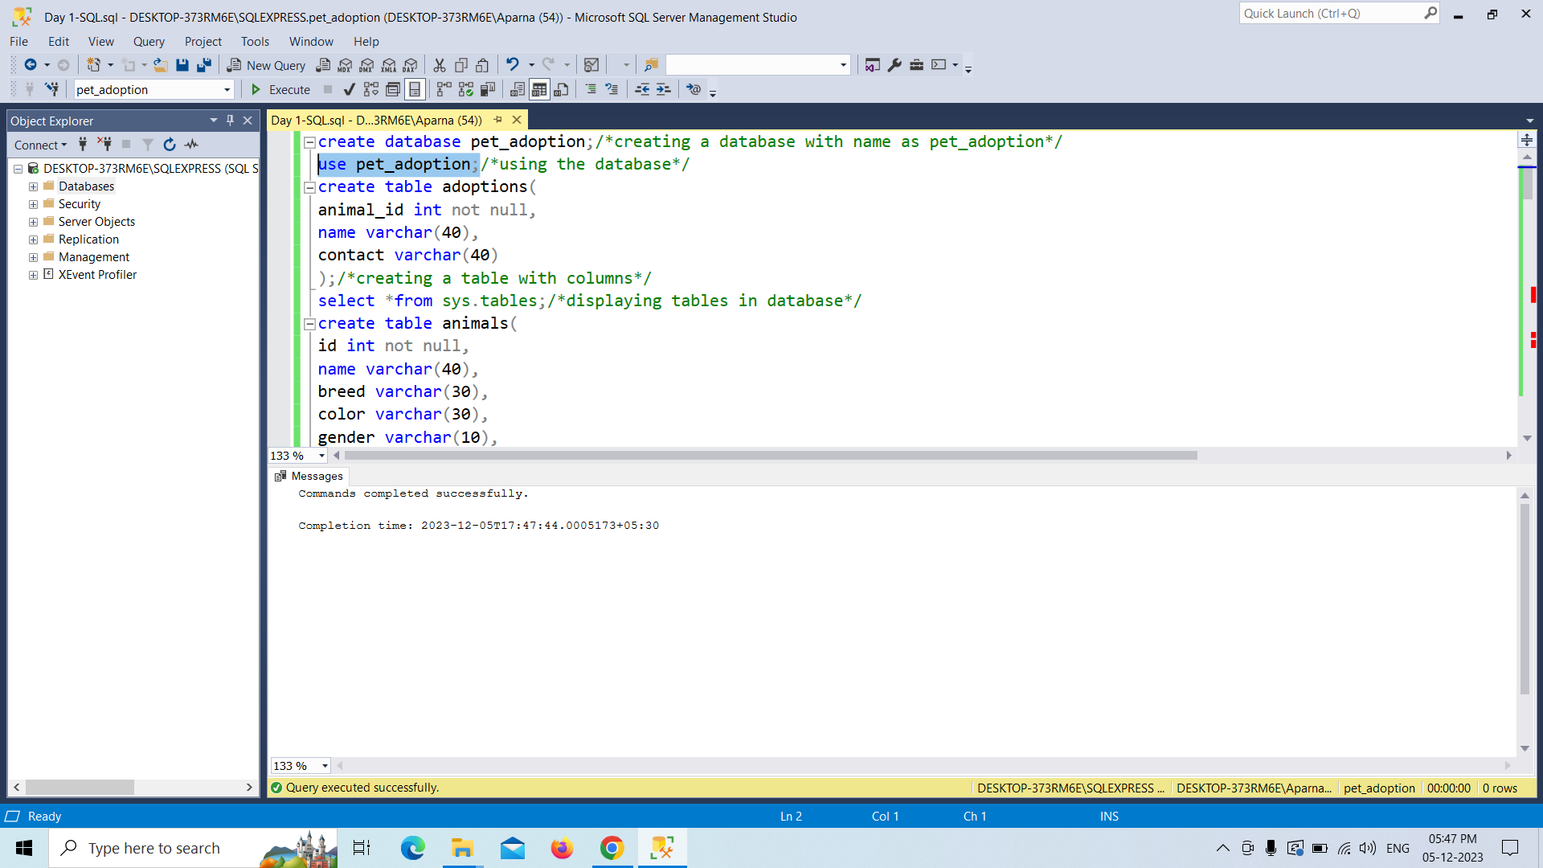

I just created the tables and displaying the tables with **select** command

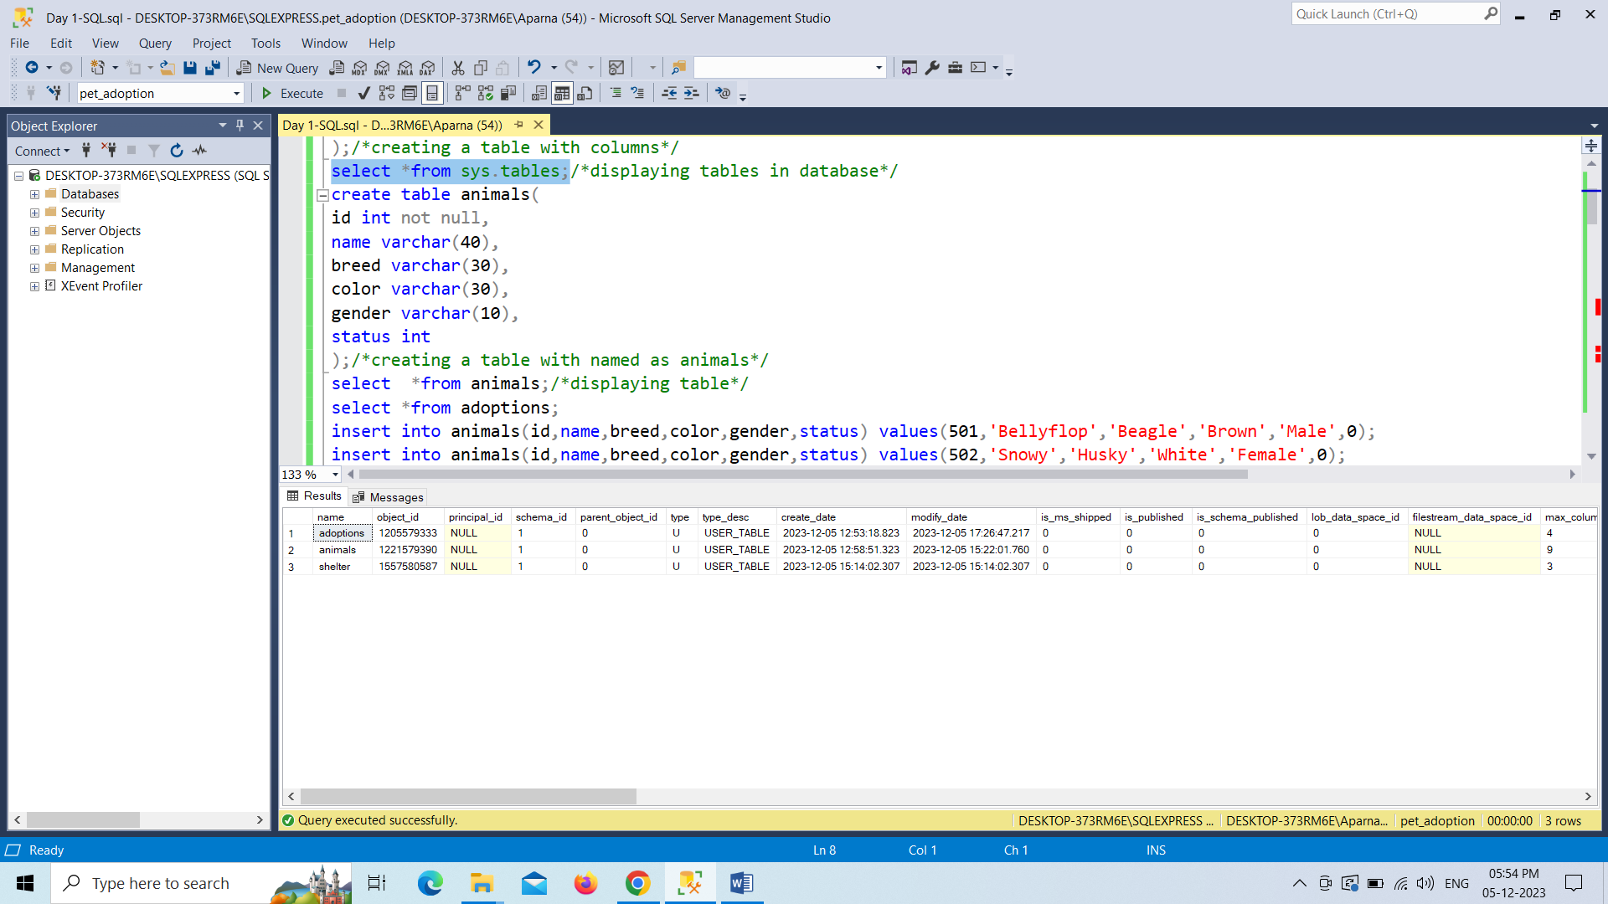

Inserted values into animals table with the insert command.

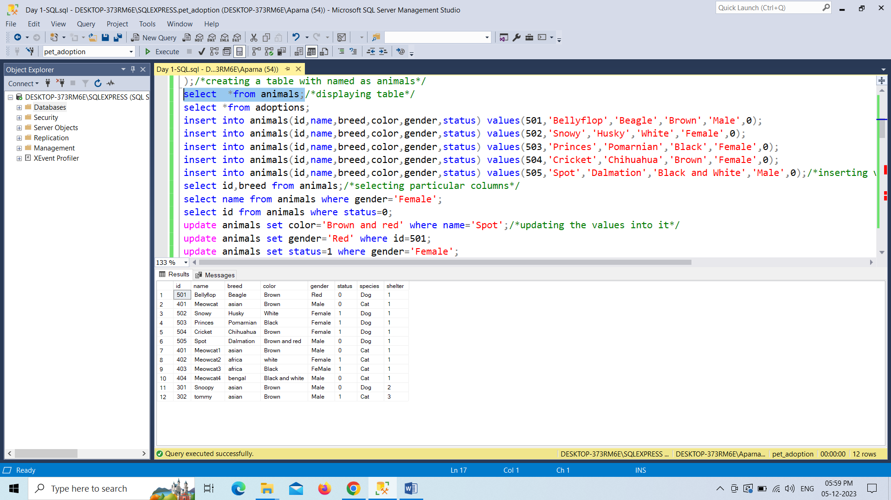

Displaying the particular records with select command.

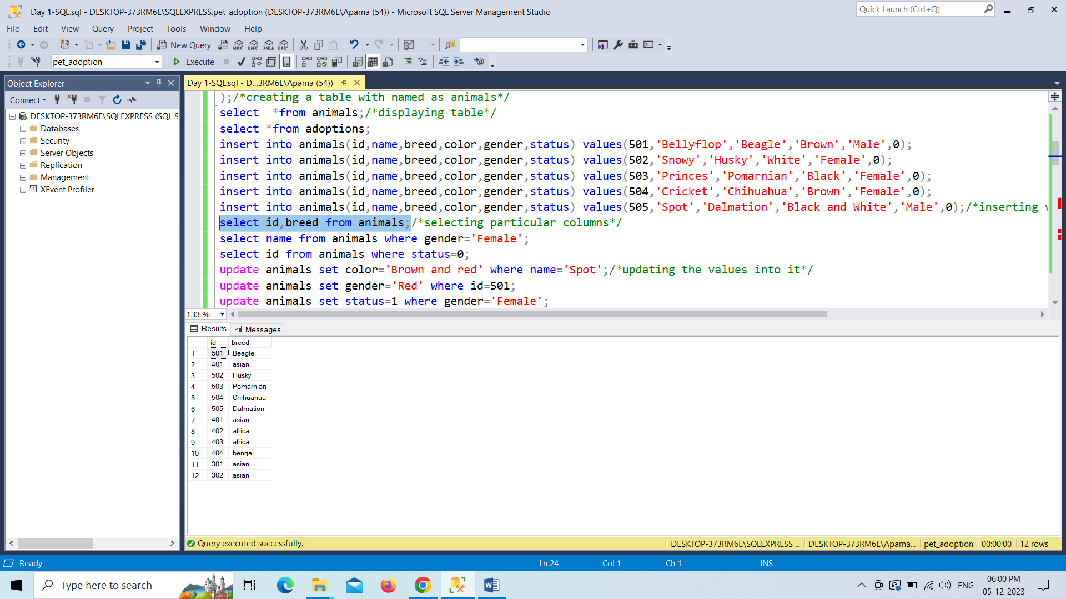

Updating records in animal table

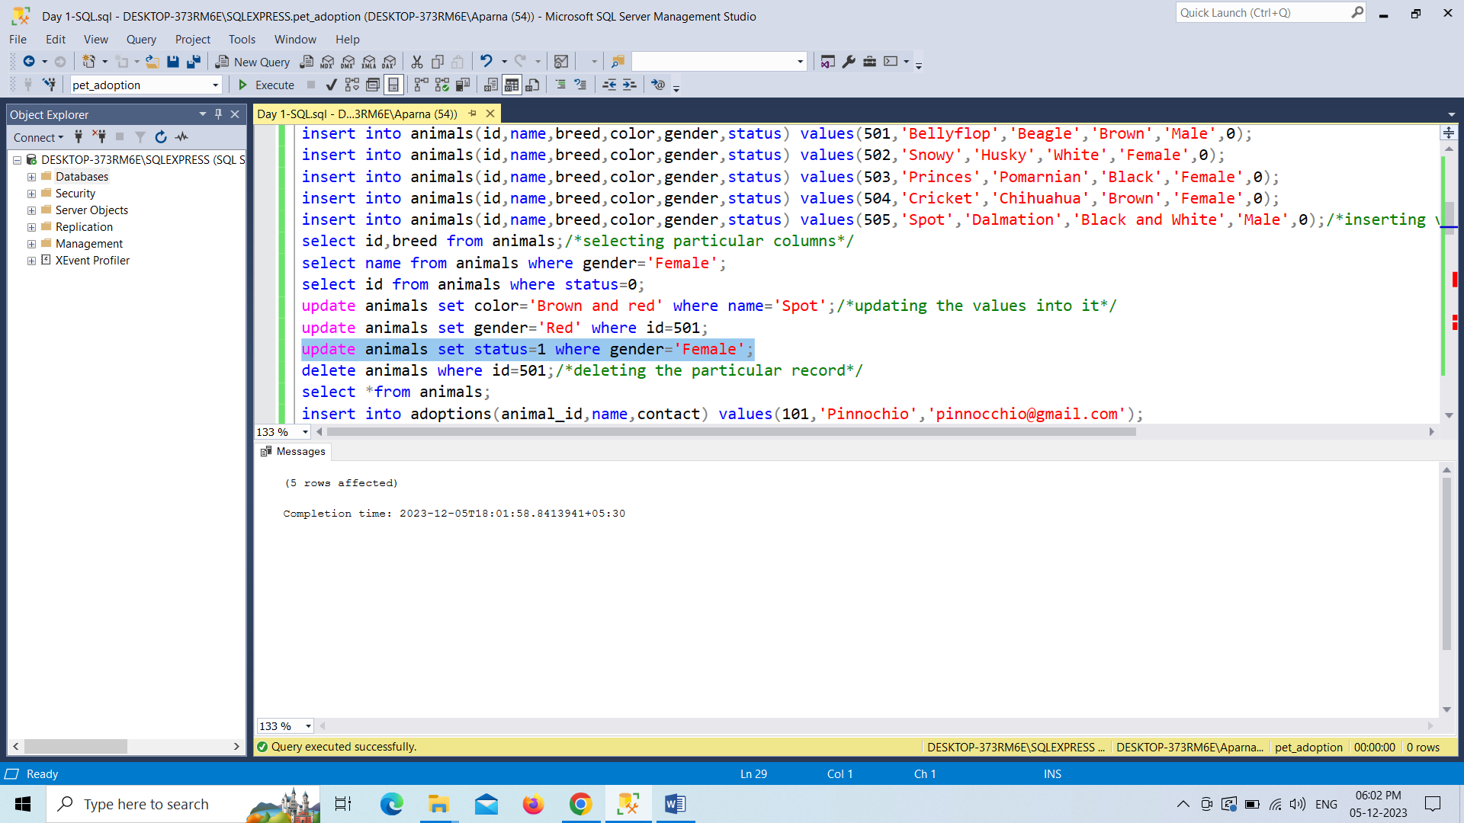

Deleting records with delete command.

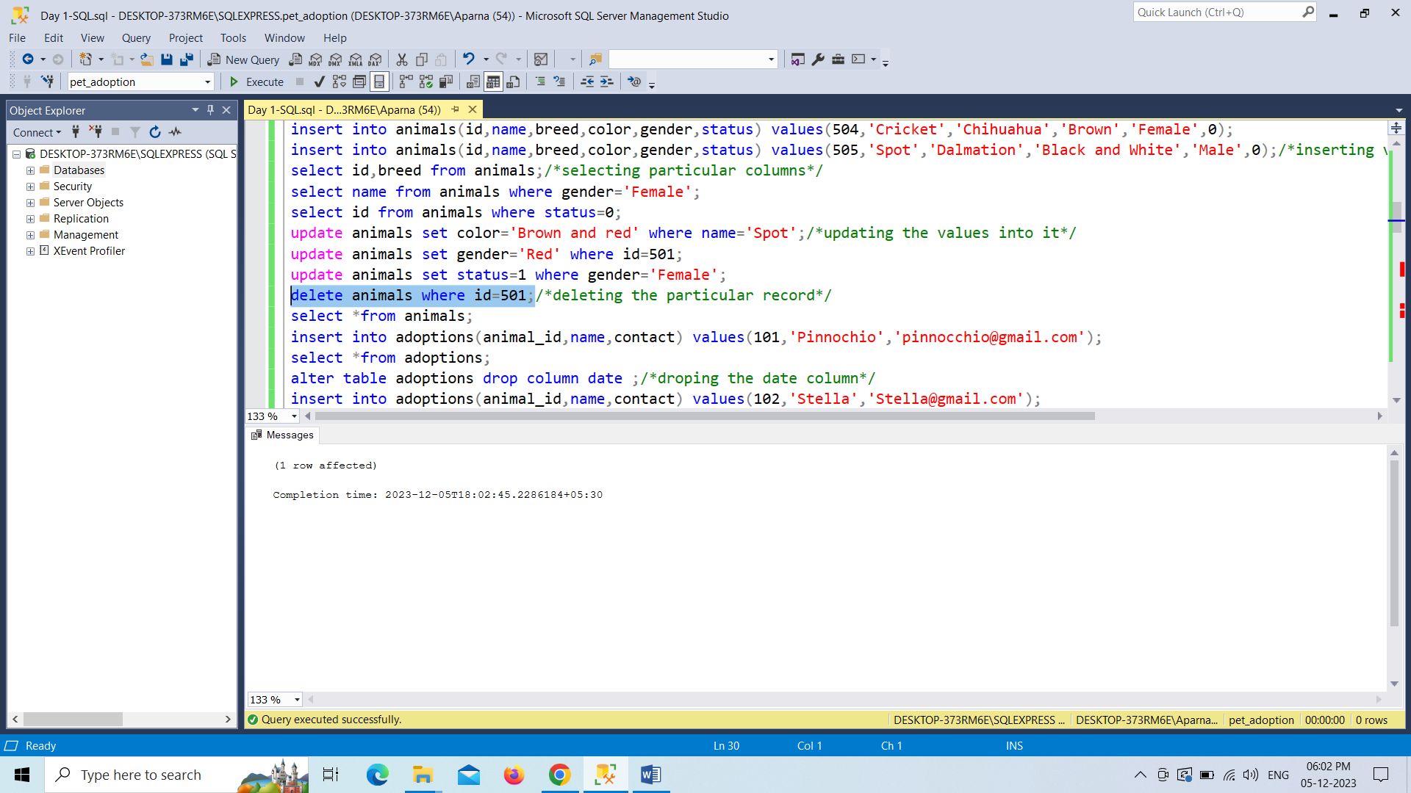

Altering table with alter command by drop a column in tables.

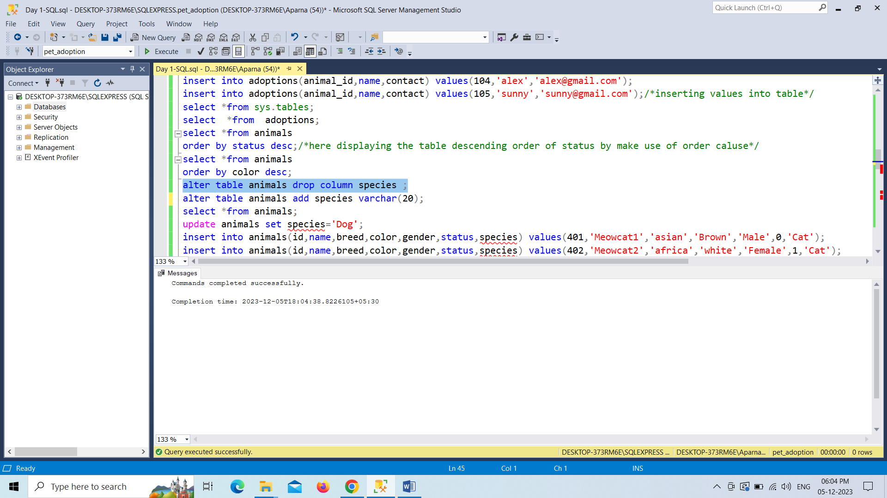

Creating a table and displaying the details of shelter table

